Laser-Assisted Cataract Surgery
Just as you have options when it comes to choosing the lens that you receive during cataract surgery, you also have the option of choosing the technology that’s used to perform the procedure. That means you have the choice between surgery performed by hand or with the assistance of laser technology.
Either type of procedure can be effective when performed by a skilled surgeon, but laser-assisted cataract surgery procedures are generally more predictable and precise. Laser-assisted cataract surgery technology can automate certain steps during the procedure with laser precision.
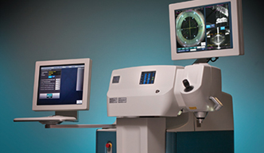
The LenSx® Laser system maps your eye, assisting in a cataract surgery that’s unique to you.

Customized Precision with the LenSx® Laser

If you opt for laser cataract surgery, your surgeon may operate using the
LenSx® Laser, which offers a level of accuracy exceeding that of manual
surgery methods. The LenSx® Laser first images your eye to plan a procedure that’s unique to you. A bladeless, computer-controlled laser then helps surgeons perform your surgery with exacting, individualized precision not attainable with traditional surgical methods.

